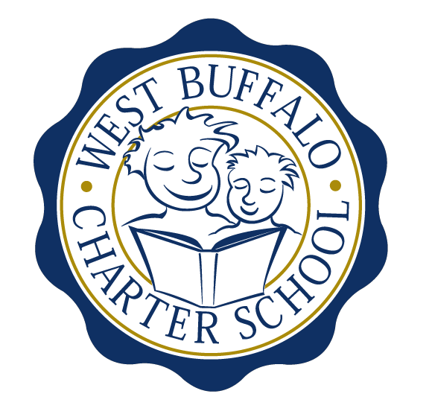

West Buffalo Charter School

Board of Trustees Meeting
February 28, 2017
2:30 PM
D’Youville College, Buffalo, New York

Board Members
Present: Michelle Stevens, Lee Pearce, Richard Baer, Amy Friedman, James Deuschle
Excused: Arup Sen, James Sampson, Joanne Haefner, Lynn Shea
Also Present: Liz Sterns
Quorum Present: Yes

Call to Order
Mrs. Stevens called the meeting to order at 2:35PM. Quorum present.

Proof of Public Notice of Meeting
Media and public announcement was sent on Friday, February 17, 2017 to print, radio, and TV outlets announcing this open meeting. A posting was also sent to Erie County Hall, Buffalo City Hall and Buffalo City Court. In addition, it was publicly displayed at 50 East North Street and posted on the WBCS website. The Board of Trustees was duly notified of this meeting well within the timeline of our bylaws.

Monthly Meeting

Review of the January 23rd, 2017 Meeting Minutes
Minutes of the January 23rd, 2017 Board of Trustees meeting were presented for approval.
Upon motion duly made by Mrs. Pearce and seconded by Mr. Deuschle, the minutes of the January 23, 2017 board meeting were approved as presented. All in favor. Non-opposed.

Financial Report
Mrs. Sterns presented the financial reports for the period ending January 31st, 2017 (a copy is attached hereto and made a part hereof).

- Proposed tour of the new building for BoT members prior to the next monthly meeting. Mrs. Sterns will email board members with potential day/time for a tour to take place.
- Mrs. Sterns presented the Facilities Committee report regarding phases IV and V. Mrs. Sterns will send out an electronic version of the building plans to the BoT.

Upon motion duly made by Mr. Baer and seconded by Mrs. Friedman, the January 31st, 2017 financial statements were approved as presented. All in favor. Non-opposed.

School Leader Report
Mrs. Todoro was not present at the meeting to present the School Leader Report.

- In regards to the upcoming ELA and Math assessment testing, Mrs. Todoro will be sending a letter to families of 3rd-5th graders. It will address such topics as the myths that surround testing time.

- Mrs. Sterns gave an overview of the trip to New York City on February 27th that she and Mrs. Todoro made to present to the NY State Education Department.

- The 2017-2018 school calendar will be up for vote once the BPS calendar is approved by the School Board.

Adjournment
Being that there is no further business to discuss, a motion to dismiss was made by Mrs. Pearce and seconded by Mrs. Friedman. The meeting was adjourned 3:40 PM.

Respectfully submitted,
Leslie Bunis Ohl

The next WBCS board meeting will take place on Monday, March 27th, 2:30 PM at D’Youville College, Bauer Family Academic Center, Room 105.

